Project Design Phase-II
Technology Stack (Architecture & Stack)

Date | 30 September 2026
Team ID | SWTID-2026-2617
Project Name | Streamlining IT Procurement: Automating Standard Laptop Orders with Flow Designer
Team Size | 4
Team Leader | Goushikram G
Team Members | Santhosh Karthick A  Jason Selvin Raj J  Abutharick M
Maximum Marks | 4 Marks

Technical Architecture:
The Deliverable shall include the architectural diagram as below and the information as per the table1 & table 2
Architecture: Standard laptop order automation on ServiceNow (Flow Designer)
Reference video: https://youtu.be/3nsUWtzpDz4
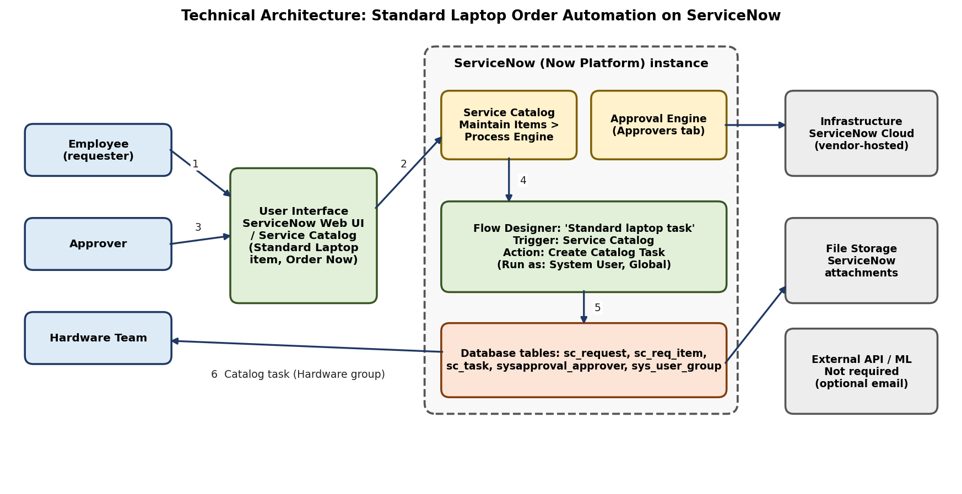
1. The employee opens the Service Catalog, selects Standard Laptop and places the order.
2. The Service Catalog (with the flow attached through Maintain Items > Process Engine) creates the request and requested item.
3. The approver approves the request from the Approvers section.
4. The Service Catalog trigger starts the Flow Designer flow "Standard laptop task".
5. The Create Catalog Task action writes the task to the database (sc_task).
6. The catalog task (Assignment group: Hardware) is available to the hardware team for configuration.

Table-1 : Components & Technologies:
S.No | Component | Description | Technology
 | User Interface | How the employee, approver and hardware team interact with the application: Service Catalog (Hardware > Standard Laptop > Order Now), Approvers section, Catalog Tasks. | ServiceNow Web UI / Service Catalog
 | Application Logic-1 | Flow "Standard laptop task" (Application: Global, Run as: System User) started by the Service Catalog trigger. | ServiceNow Flow Designer
 | Application Logic-2 | Create Catalog Task action: Requested Item, short description and description "Laptop needs to Configured", Assignment group = Hardware, Approval = Approved. | Flow Designer action (ServiceNow Core)
 | Application Logic-3 | Approval of the request by the approver; flow attached to the Standard Laptop item via Process Engine. | ServiceNow Approvals, Catalog Item Process Engine
 | Database | Relational tables: sc_request, sc_req_item, sc_task, sysapproval_approver and sys_user_group. | ServiceNow platform database
 | Cloud Database | Database is hosted and managed in the ServiceNow cloud instance. | ServiceNow cloud database
 | File Storage | Attachments on requests or tasks, if any, are stored by the platform. | ServiceNow attachment storage
 | External API-1 | Not used in the current scope (optional email notification in future). | N/A
 | External API-2 | Not used in the current scope. | N/A
 | Machine Learning Model | Not applicable; the solution is rule-based automation. | N/A
 | Infrastructure (Server / Cloud) | Local server configuration: none (no local deployment).  Cloud server configuration: ServiceNow-hosted instance. | ServiceNow Cloud (Now Platform)

Table-2: Application Characteristics:
S.No | Characteristics | Description | Technology
 | Open-Source Frameworks | The solution is built on a low-code platform, so no open-source framework is developed. | ServiceNow Flow Designer (low-code)
 | Security Implementations | Login authentication, role-based access, approval before task creation, flow runs as System User, platform access controls. | ServiceNow roles / ACLs
 | Scalable Architecture | Multi-tier design (user interface, flow logic, database) on the platform. The flow can be reused for other catalog items. | Service Catalog, Flow Designer
 | Availability | Hosted on the ServiceNow cloud, which provides managed infrastructure for the application. | ServiceNow Cloud
 | Performance | Event-driven: the task is created automatically when the trigger fires, with no manual step. | Flow Designer trigger and action

References:
https://c4model.com/
https://youtu.be/3nsUWtzpDz4
https://developer.ibm.com/patterns/online-order-processing-system-during-pandemic/
https://www.ibm.com/cloud/architecture
https://aws.amazon.com/architecture
https://medium.com/the-internal-startup/how-to-draw-useful-technical-architecture-diagrams-2d20c9fda90d

